Day11 28th April 2025 MongoDB practical

create sampledb

sample collection

use sampledb;

db.dropdatabase;

create checkdb;

sampledata collection

use sampledata

db.sampledata.drop()

4.b.degrees.deleteOne({_id:ObjectId('680ee932267c3a1fb9d5ab1b')});

{

acknowledged: true,

deletedCount: 1

}

5.db.degrees.find().projection(['name','duration']);

6.db.degrees.find({},{name:1,_id:0}).pretty()

7.db.degrees.deleteMany({duration:{$lt:4}})

8.db.degrees.updateOne({_id:ObjectId('680eef9b267c3a1fb9d5ab21')},{$set:{name:'BIT',duration:3}}) //updateOne

9.db.degrees.updateMany({duration:{$gte:4}},{$inc:{duration:1}})

10.db.degrees.find();

11.db.students.updateOne({regno:'2021ict001'},{$push:{skills:'PHP'}});

12.db.students.findOne({regno:'2021ict001'})

db.books.insertMany(

[

{

"title": "The Hobbit",

"author": "J.R.R. Tolkien",

"published_year": 1937,

"genres": ["Fantasy", "Adventure"],

"pages": 310,

"available": true,

"rating": 4.8

},

{

"title": "1984",

"author": "George Orwell",

"published_year": 1949,

"genres": ["Dystopian", "Political Fiction"],

"pages": 328,

"available": true,

"rating": 4.7

},

{

"title": "To Kill a Mockingbird",

"author": "Harper Lee",

"published_year": 1960,

"genres": ["Southern Gothic", "Drama"],

"pages": 281,

"available": false,

"rating": 4.6

},

{

"title": "The Great Gatsby",

"author": "F. Scott Fitzgerald",

"published_year": 1925,

"genres": ["Tragedy"],

"pages": 180,

"available": true,

"rating": 4.4

},

{

"title": "Brave New World",

"author": "Aldous Huxley",

"published_year": 1932,

"genres": ["Science Fiction", "Dystopian"],

"pages": 311,

"available": true,

"rating": 4.2

}

]

);

**1.Find all books**

db.books.find();

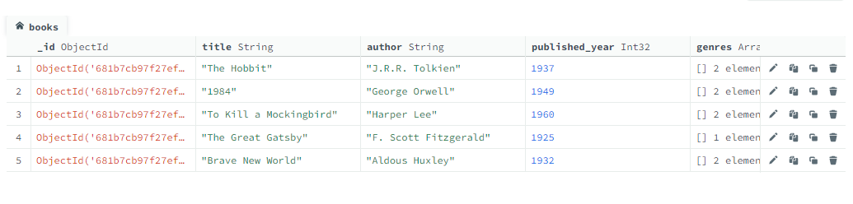

**2.Find all books published after 1950**

db.books.find({published_year:{$gt:1950}})

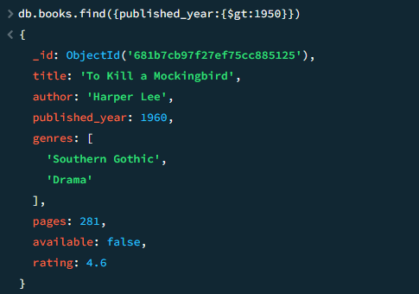

**3.Find the avilable books**

db.books.find({available:true})

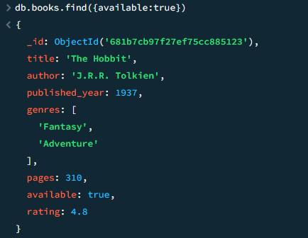

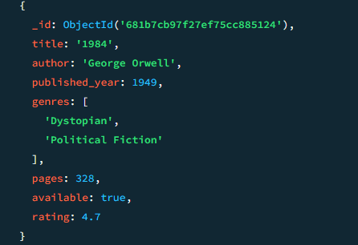

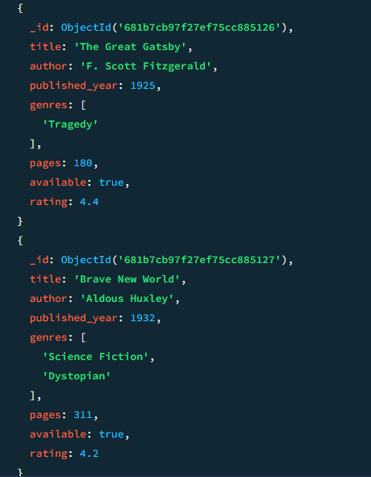

**4.Find all books that belong to the "Dystopian" genre**

db.books.find({genres:"Dystopian"})

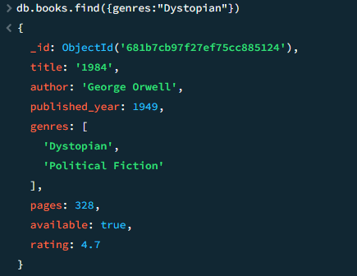

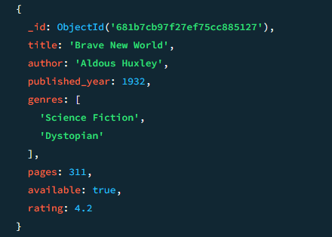

**5.Find the books which published after 1960 and had rating more than 4.0.**

db.books.find({published_year:{$gt:1950},rating:{$gt:4.0}})

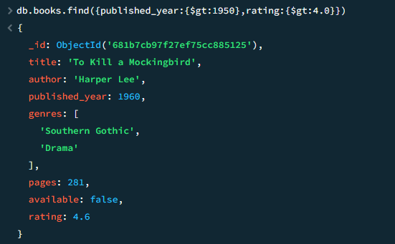

**6.Project only title and author fields:**

db.books.find({title:1,author:1,_id:-1})

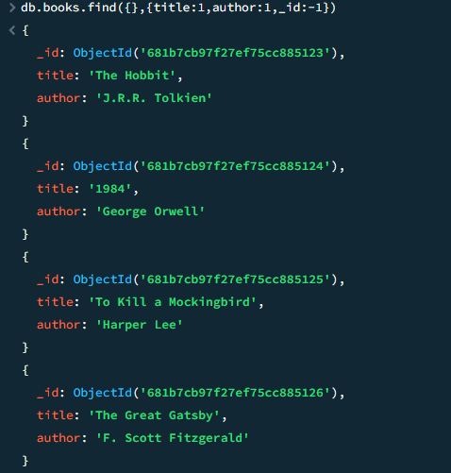

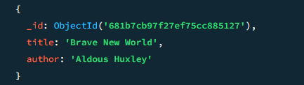

**7.Update the book "1984" to set available: false:**

db.books.updateOne.({title: “1984”},{$set:{available: false}})

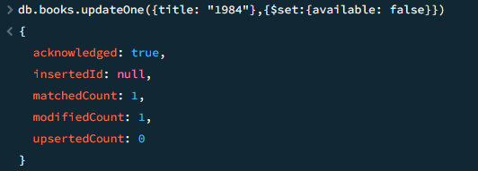

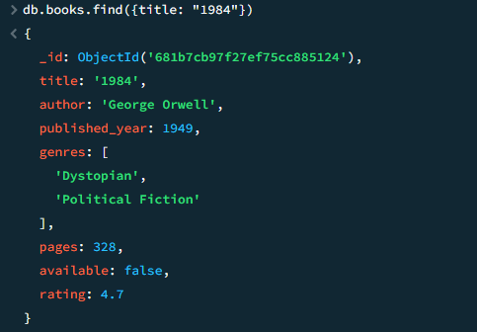

**8.Increase the rating of "Brave New World" by +0.1:**

db.books.updateOne({title:” Brave New World”}, {$inc: {rating: 0.1}})

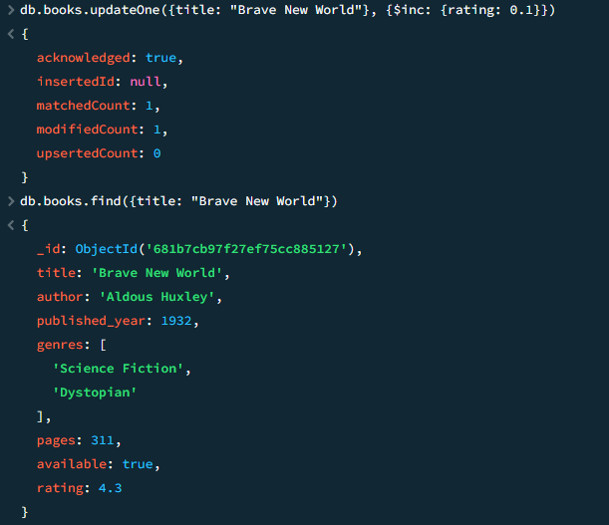

**9.Add a new genre "Classic" to "The Great Gatsby":**

Db.books.updateOne({title: “The Great Gatsby”}, {$addToSet: {genre: “Classic”}})

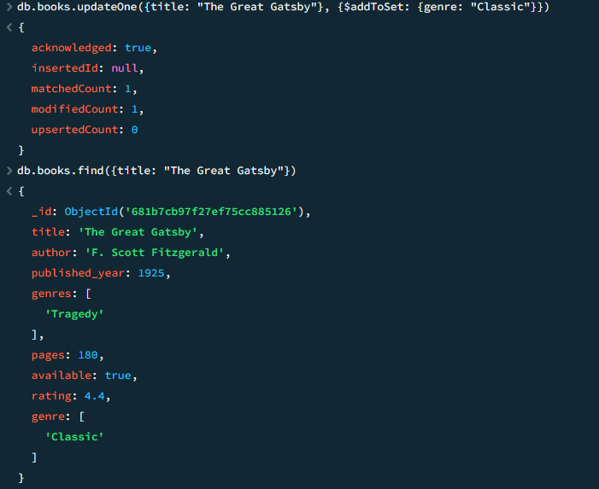

**10.Sort books by published_year ascending:**

db.books.find().sort({published_year:1})

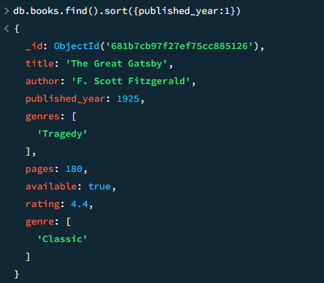

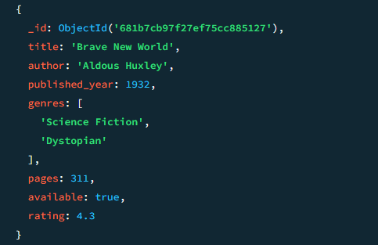

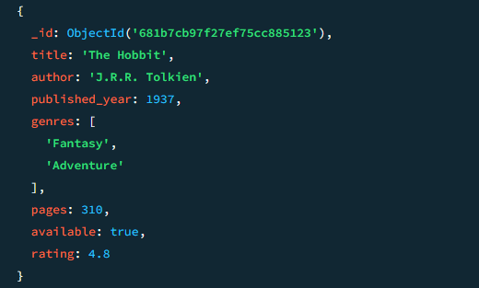

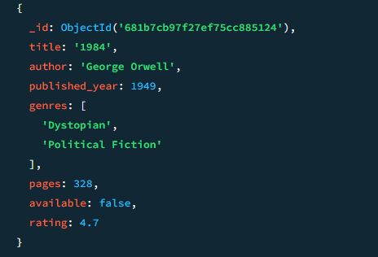

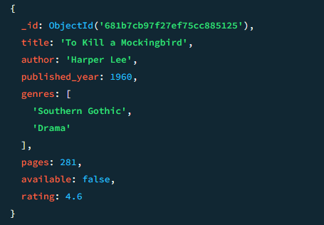

**11.Sort books by rating descending:**

db.books.find().sort({rating: -1})

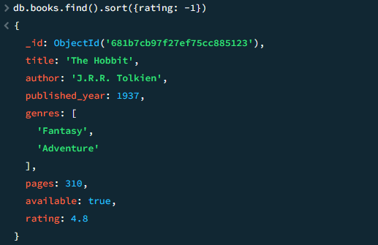

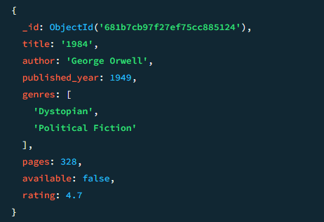

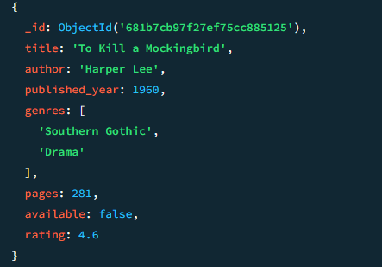

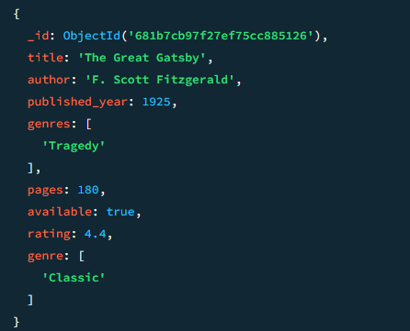

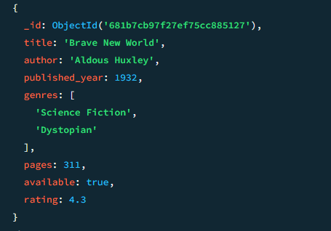

**12.Delete all books with a rating lower than 4.5:**

db.books.deleteMany({rating: {$lt: 4.5 }})

